Nosecone and Trajectory Analysis

MAE 157A: Fluid Mechanics and Aerodynamics Laboratory

**Prescott Rynewicz, UCLA MAE Undergraduate Student**

Professor

R. Mitchell Spearrin, Ph.D.



Table of Contents

Introduction 3

List of Tables 4

List of Figures 5

Individual Tasks 6

Results 6

Nosecone Fluent Analysis 6

Discussion 11

Team Tasks 13

Wind Tunnel Testing 14

Fiberglass Nosecone Molding 19

Trajectory Analysis 21

Amazon C6-3 22

Big Bertha B6-4 25

Bull Pug B6-4 28

Trajectory Discussion 31

Plot Discussion 31

Affect Of Mass 31

Effect of Launch Angle 31

Malfunctioning Altimeter 31

Launch Angle Controller 33

Manufacturing Plan 35

Summary and Conclusions 41

Statements of Participation 42

Individual Tasks 42

Team Tasks 42

Team Members Rated 42

Appendices 43

Matlab Code 43

Sample Wind Tunnel Data 45

Images 46

# **Introduction**

This lab focuses on the modeling and analysis of the nosecone within a rocket system, the trajectory of a rocket system and the impact that the nosecone has on the trajectory analysis. To perform the nosecone analysis, CFD simulations using Fluent are run on a series of different nosecones at different speeds. These simulations are able to calculate the lift and drag due to the nosecone, which play a significant role in determining the overall lift and drag for the vehicle. After this, wind tunnel tests with a series of different nose cones are conducted. These numerical wind tunnel results are used as a comparison against the theoretical values found in Fluent. Finally, a trajectory analysis is completed on a set of model rockets. The rockets themselves have been launched and collected data for their altitude vs. time in a real-world setting. These experimental results and compared against several matlab simulations using different drag values for burn, coast and recovery. A launch angle controller is also designed and manufactured for this lab, to have precise launch control for angle of attack between 0 and 30 degrees.

# **List of Tables**

Table of Contents 2

Table 1: Nosecone CFD Test Cases. 6

Table 2: Sources of Drag. 12

Table 3: CFD Numerical Results. 12

Table 3a: Team Task Responsibility Assignment 13

Table 4: Tabulated drag values for each nose cone shape at velocities from 5-30 m/s 15

Figure 14: Graph of drag coefficient vs. Reylonds number for four different nose cones 16

Table 5: Amazon C6-3 Numerical Results for Three Different Simulations. 23

Table 6: Big Bertha B6-4 Numerical Results for Three Different Simulations. 26

Table 7: Bull Pug B6-4 Numerical Results for Three Different Simulations. 29

# List of Figures

Figure 1: Static Pressure Contour Plot for Conical Nose Cone at 20 [m/s] 7

Figure 2: Velocity Magnitude Contour Plot for Conical Nose Cone at 20 [m/s] 7

Figure 3: Pressure Coefficient Plot for Conical Nose Cone at 20 [m/s] 7

Figure 4: Static Pressure Contour Plot for Conical Nose Cone at 90 [m/s] 8

Figure 5: Velocity Magnitude Contour Plot for Conical Nose Cone at 90 [m/s] 8

Figure 6: Pressure Coefficient Plot for Conical Nose Cone at 90 [m/s] 8

Figure 7: Static Pressure Contour Plot for ½ Power Nose Cone at 20 [m/s] 9

Figure 8: Velocity Magnitude Contour Plot for ½ Power Nose Cone at 20 [m/s] 9

Figure 9: Pressure Coefficient Plot for ½ Power Nose Cone at 20 [m/s] 9

Figure 10: Static Pressure Contour Plot for ½ Power Nose Cone at 90 [m/s] 10

Figure 11: Velocity Magnitude Contour Plot for ½ Power Nose Cone at 90 [m/s] 10

Figure 12: Pressure Coefficient Plot for ½ Power Nose Cone at 90 [m/s] 10

Figures (Clockwise from top left) 13: Process of collecting wind tunnel data for nose cone analysis 14

Figure 15: Graph of average drag force on each nose cone vs Reynolds number 17

Figure 16: Finished Nose Cone Mold 19

Figure 17: 3D Printed mold used for Fiberglass Nosecone. 20

Figure 18: Amazon C6-3 Trajectory Analysis with No Drag 22

Figure 19: Amazon C6-3 Trajectory Analysis with Drag Condition 1. 22

Figure 20: Amazon C6-3 Trajectory Analysis with Drag Condition 2. 23

Figure 21: Experimentally collected altimeter data for the Amazon C6-3. 24

Figure 22: Big Bertha B6-4 Trajectory Analysis with No Drag 25

Figure 23: Big Bertha B6-4 Trajectory Analysis with CD = 0.5/1.5 25

Figure 24: Big Bertha B6-4 Trajectory Analysis with CD = 0.8/2.0 26

Figure 25: Experimentally collected altimeter data for the Big Bertha B6-4. 27

Figure 26: Bull Pug Trajectory Analysis with No Drag 28

Figure 27: Bull Pug Trajectory Analysis with CD = 0.5/1.5 28

Figure 28: Bull Pug Trajectory Analysis with CD = 0.8/2.0 29

Figure 29: Experimentally collected altimeter data for the Bull Pug B6-4. 30

Figure 30: LAC Assembly Isometric View 33

Figure 31: LAC Assembly Back Isometric View 34

Figure 32: 4”x11” Material Check 34

Figure 33: Base Plate Drawing 35

Figure 34: Wall Drawing 36

Figure 35: Wall Drawing 37

Figure 36: Bolt Guide Drawing 38

Figure 37: Brass Insert Drawing 38

Figure 37: Rocket Insert Drawing 39

# **Individual Tasks**

## Results

### Nosecone Fluent Analysis

For the CFD analysis of various nosecones section, two different nosecones are used at two different conditions. This results in four total cases to examine the effects of velocity, and nose cone shape. The table below represents the test cases used in this lab.

|  |  |  |
| --- | --- | --- |
| Nosecone Shape | Input Velocity [m/s] | Angle of Attack [deg] |
| Conical : R = 4in - L = 8in | 20 | 0 |
| Conical : R = 4in - L = 8in | 20 | 0 |
| ½ Power: R = 4in = L = 8in | 90 | 0 |
| ½ Power: R = 4in = L = 8in | 90 | 0 |

Table 1: Nosecone CFD Test Cases.

Plots of Pressure Coefficient, velocity and static pressure are shown below for each of the four cases above.

#### Case 1

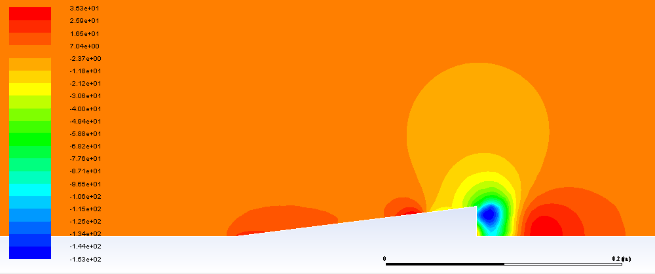

Figure 1: Static Pressure Contour Plot for Conical Nose Cone at 20 [m/s]



Figure 2: Velocity Magnitude Contour Plot for Conical Nose Cone at 20 [m/s]

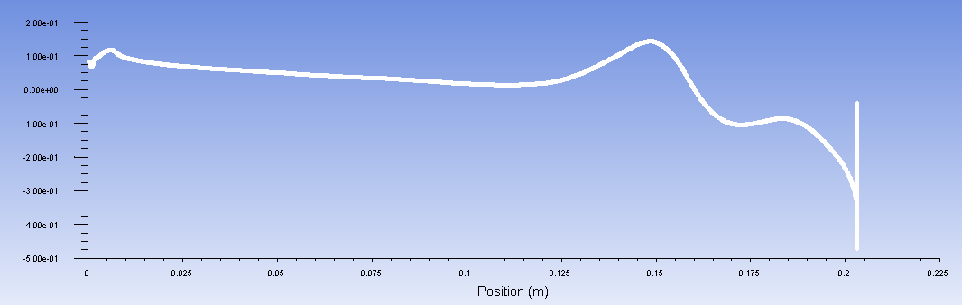

Figure 3: Pressure Coefficient Plot for Conical Nose Cone at 20 [m/s]

#### Case 2

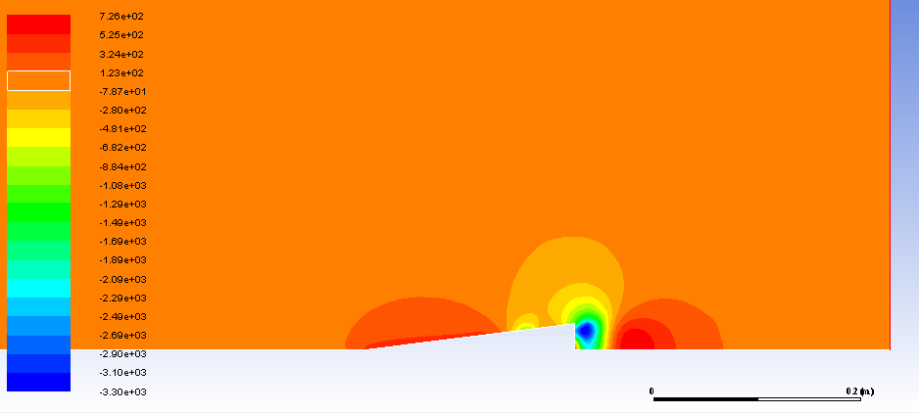

Figure 4: Static Pressure Contour Plot for Conical Nose Cone at 90 [m/s]

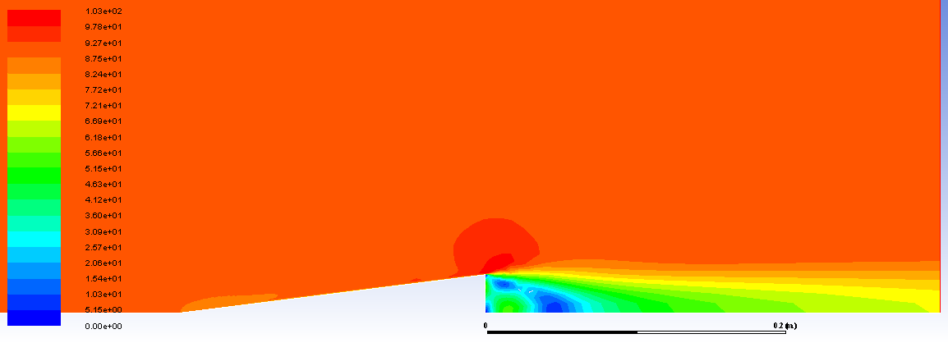

Figure 5: Velocity Magnitude Contour Plot for Conical Nose Cone at 90 [m/s]

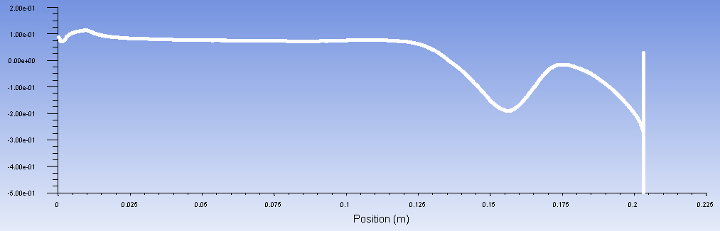

Figure 6: Pressure Coefficient Plot for Conical Nose Cone at 90 [m/s]

#### Case 3

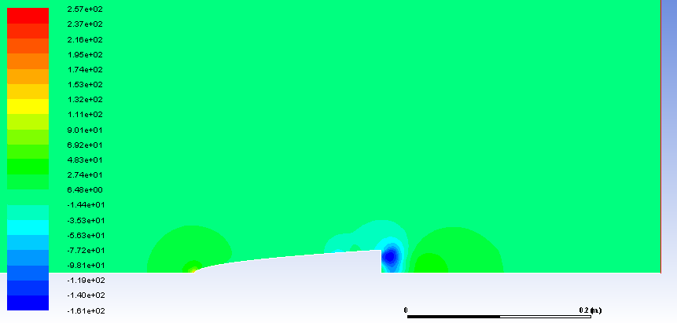

Figure 7: Static Pressure Contour Plot for ½ Power Nose Cone at 20 [m/s]

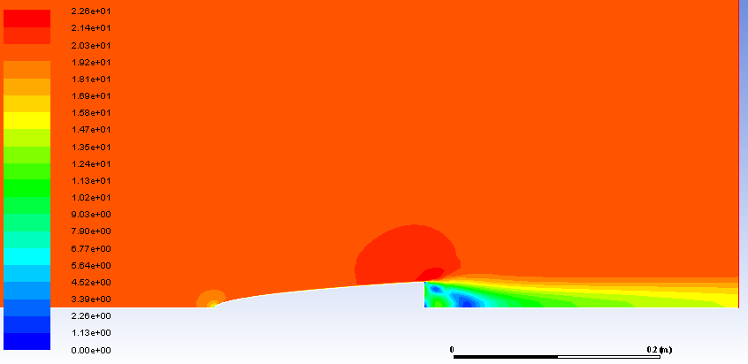

Figure 8: Velocity Magnitude Contour Plot for ½ Power Nose Cone at 20 [m/s]

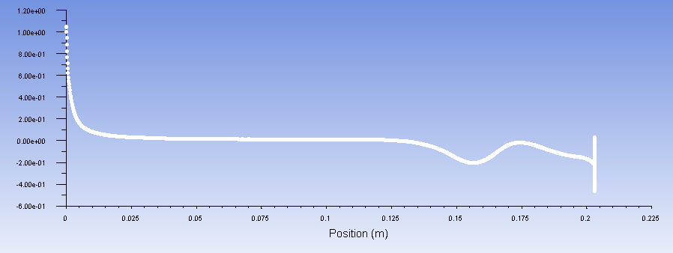

Figure 9: Pressure Coefficient Plot for ½ Power Nose Cone at 20 [m/s]

#### Case 4

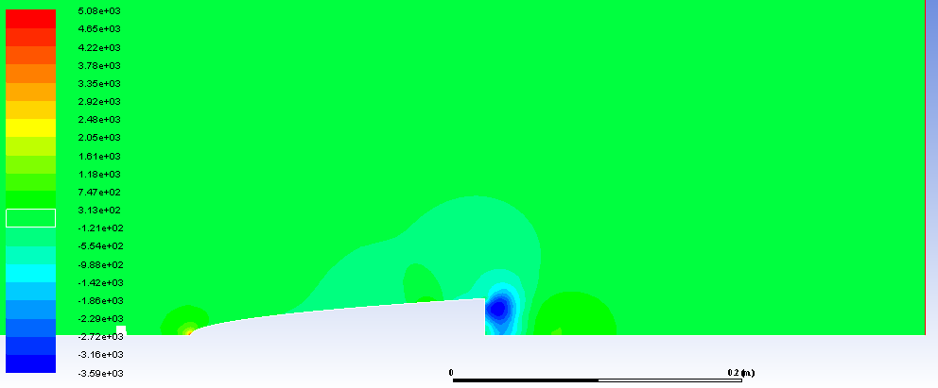

Figure 10: Static Pressure Contour Plot for ½ Power Nose Cone at 90 [m/s]

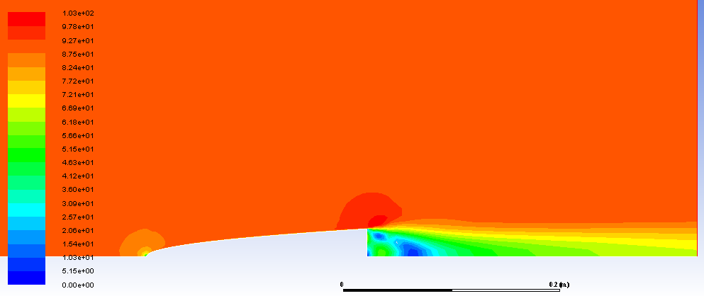

Figure 11: Velocity Magnitude Contour Plot for ½ Power Nose Cone at 90 [m/s]

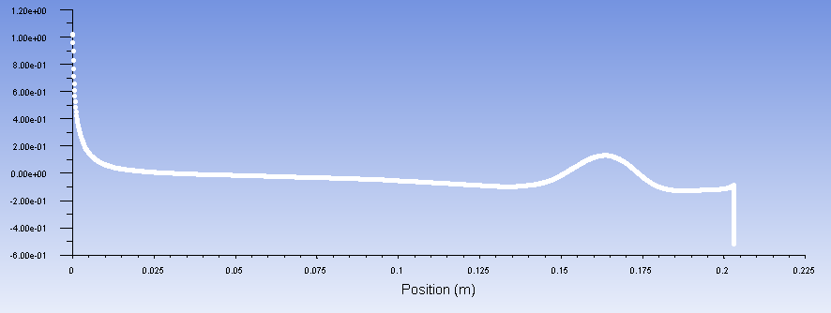

Figure 12: Pressure Coefficient Plot for ½ Power Nose Cone at 90 [m/s]

## Discussion

#### Static Pressure Plots

The static pressure plots for all four cases show very similar trends. At the tip of the nosecone where the impact with oncoming air is first made, there is a very high pressure spike. Along the majority of the body of the nosecone, very little pressure changes occur, and the static pressure is very similar to the freestream pressure as well. The last noticeable pressure difference is the area trailing the nosecone, where pressure drops drastically. This is due to the sharp end at the end of the nosecone. The high pressure at the tip of the nosecone, and the low-pressure area trailing the nosecone are what contribute to the drag created by the nosecone.

#### Velocity Magnitude Plots

The Velocity plots results in quite similar trends to the static pressure, as static pressure is directly depending on the relative velocity of the flow. A pinpointed area of low velocity is found at the tip of the nosecone, and the wake of the nosecone shows an extended area of low velocity gradient.

#### Pressure Coefficient

The pressure coefficient plots align well with the static pressure plots as well. All four cases show a spike in coefficient values at the tip of the nosecone. This spike slowly decreases over the length of the nosecone, and eventually dips to a very low value in the area after the end of the nosecone. One interesting feature for the conical nosecone, is that the pressure coefficient experiences a transient state between the last 10-20% of the length of the nosecone before dropping off in the area behind the nosecone.

#### Sources of Drag

When performing the Fluent simulations, a portion of the results includes percentages impact from viscosity and pressure which contribute to drag. These results are shown in the table below.

|  |  |  |  |
| --- | --- | --- | --- |
| Nose Cone | Flow Velocity [m/s] | Viscous Contribution | Pressure Contribution |
| Conical | 20 | 12.80% | 87.20% |
| Conical | 90 | 10.56% | 89.44% |
| Half Power | 20 | 18.36% | 81.64% |
| Half Power | 90 | 13.77% | 86.23% |

Table 2: Sources of Drag.

#### Base Drag

Base drag is a portion of aerodynamic drag that arises from creating a partial vacuum just behind the end of the rocket. Base drag plays an important role in the Fluent Simulations. As discussed with the presented plots, the highest areas of interest and change occur right after the nosecone ends and opens into free space. This drastic change in volume available for air to fill creates a partial vacuum behind the nosecone. This creates areas of extremely low velocity and low pressure.

#### Total Results

|  |  |  |  |  |  |
| --- | --- | --- | --- | --- | --- |
| **Nose Cone** | **Flow Velocity [m/s]** | **Drag Coefficient** | **Lift Coefficient** | **Lift Force [N]** | **Drag Force [N]** |
| Conical | 20 | 0.399 | -3.74E-05 | -1.85E-05 | 0.1977 |
| Conical | 90 | 0.364 | -3.12E-03 | -0.0333 | 3.654 |
| Half Power | 20 | 0.357 | 1.81E-03 | 8.96E-04 | 0.177 |
| Half Power | 90 | 0.366 | -4.29E-03 | -0.0431 | 3.683 |

Table 3: CFD Numerical Results.

# Team Tasks

The team assignments for this lab are broken up into different sections and the responsibilities for each tasks are tabulated below.

|  |  |  |
| --- | --- | --- |
| Task Area | Experimental Testing | Analysis and Report |
| Wind Tunnel Testing | Prescott Rynewicz  Hunter Kenyon | Hunter Kenyon  Jordan Robertson |
| Fiberglass Nosecone Mold | Sunderlin Jackson  Lukas Kramer | Sunderlin Jackson  Lukas Kramer |
| Trajectory Analysis | Prescott Rynewicz | Prescott Rynewicz |
| Launch Angle Controller | Sunderlin Jackson  Lukas Kramer | All |

Table 3a: Team Task Responsibility Assignment

## Wind Tunnel Testing

#### Tabulate Drag

To find the necessary parameters for the team section analysis we utilized a wind tunnel and placed four different nose cone shapes with length of 8 inches and various fineness ratios in the airflow to measure the displacement and forces. These nose cones were a conical with fineness ratio of 4, conical nose cone with fineness ratio of 1, cylindrical nose cone with fineness ratio of 4, and the half power nose cone with fineness ratio of 4. Once mounted in the wind tunnel we varied velocity 6 times and recorded data 10 times at each velocity. This process can be seen in Figure 13. The results for the nose cones were then averaged for each velocity.

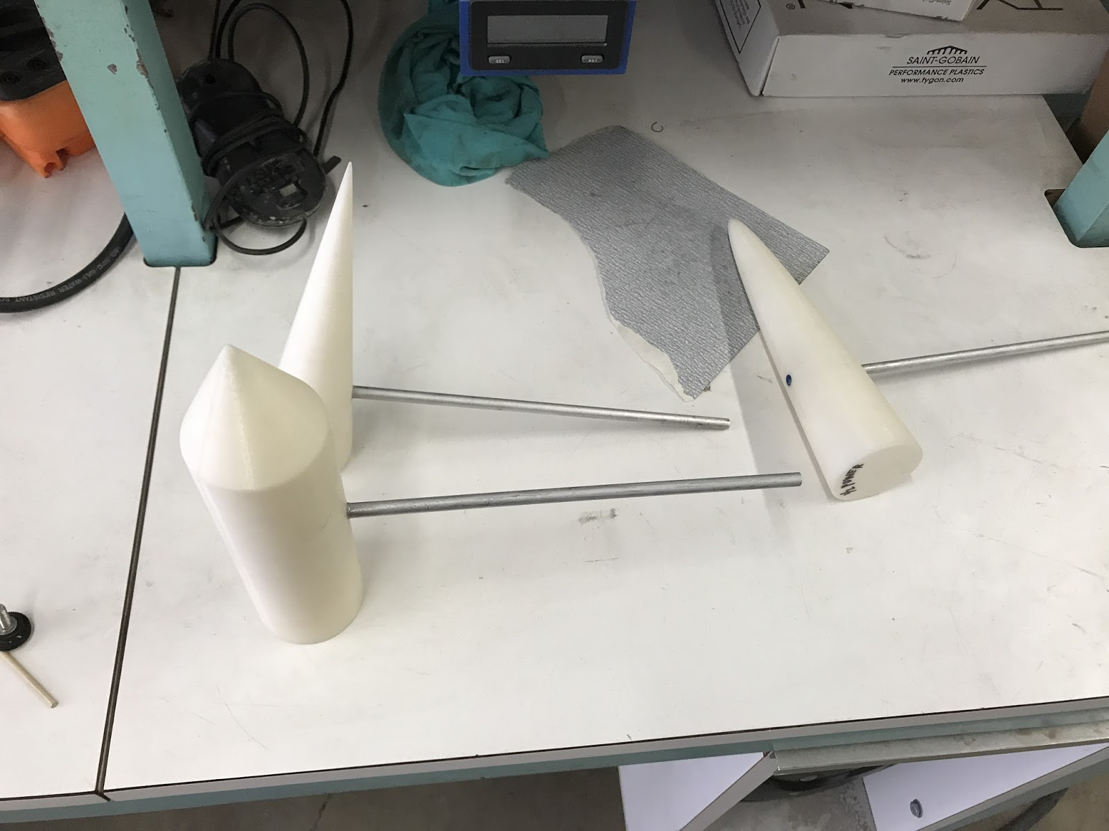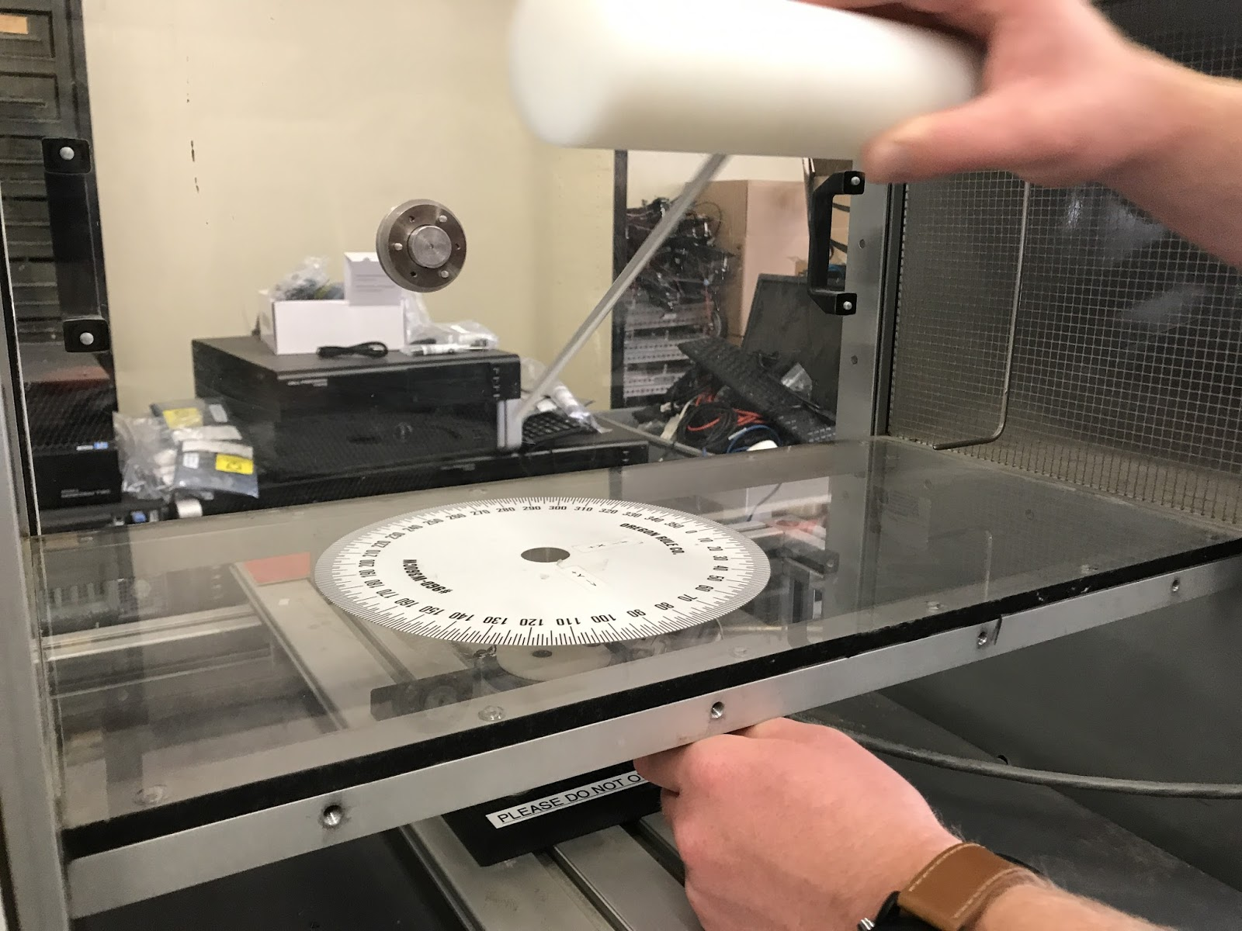

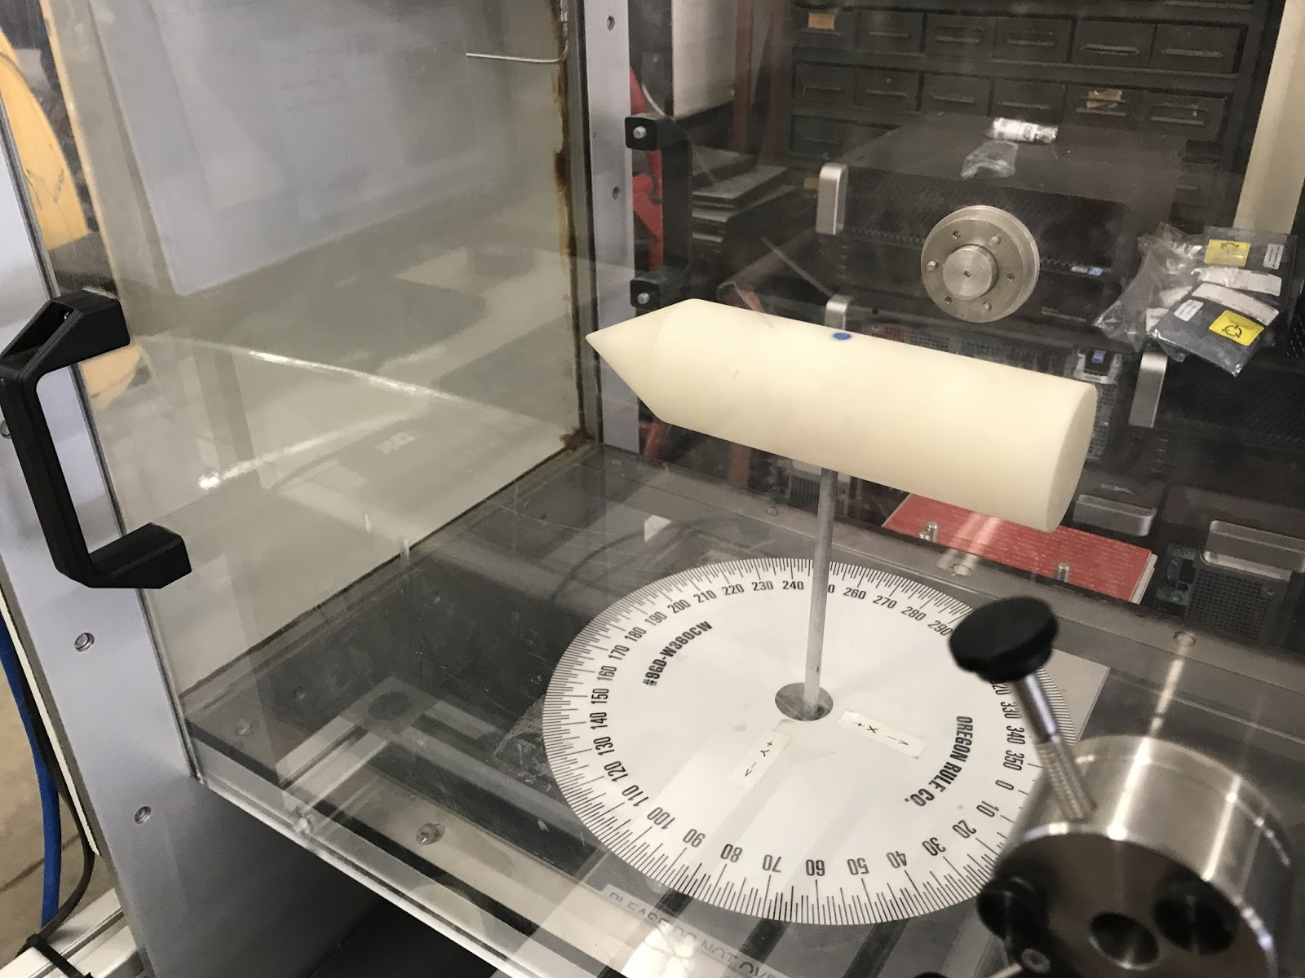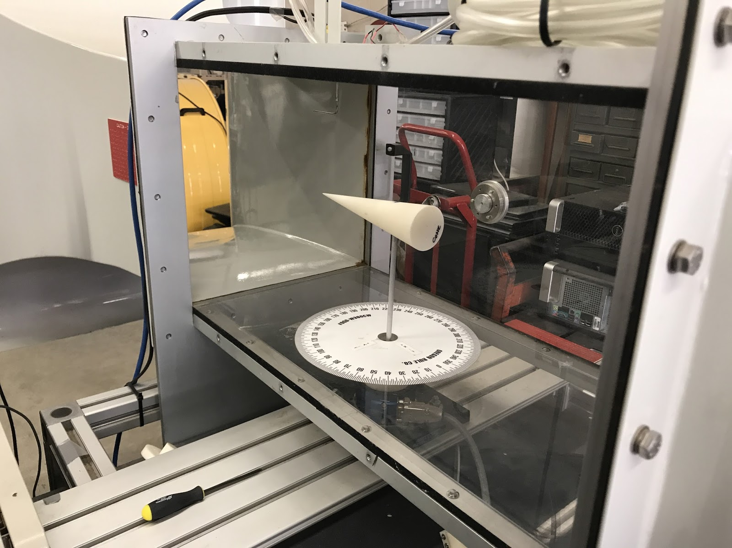

Figures 13: Process of collecting wind tunnel data for nose cone analysis

|  |  |  |  |  |
| --- | --- | --- | --- | --- |
| Velocity [m/s] | Conical, Fine=4 | Conical, Fine=1 | Cylinder | Half Power |
| 5 | 0.1322743 | 0.1365987 | 0.2179025 | 0.1760314 |
| 10 | 0.2025019 | 0.2442353 | 0.3844413 | 0.2913379 |
| 15 | 0.3933115 | 0.4119594 | 0.7607402 | 0.5379255 |
| 20 | 0.7554162 | 0.026852 | 0.079562 | 0.1155024 |
| 25 | 0.9765674 | 0.8279638 | 1.4722211 | 1.035065 |
| 30 | 1.1955652 | 1.1284157 | 2.1818491 | 1.1590491 |

Table 4: Tabulated drag values for each nose cone shape at velocities from 5-30 m/s

It’s important to note that from further analysis presented in sections III and IV that we believe some errors occurred when collecting our wind tunnel analysis. These drag values appear too high when compared to the expected drag values for these nose cones. A possible source of the error comes from the sensitivity of the transducers in the wind tunnel. This manifests itself through larger than expected values at lower velocities, with this uncertainty being reduced as the velocity increases.

#### Lift Forces

By referring to the lift forces found from the wind tunnel testing on all four nose cone shapes we were able to determine that while some lift forces were observed, they were insignificant and should not affect the performance of the nose cone. For example, the average lift force for the conical with fineness ratio of 4 was 0.0195 N, when compared with the average drag force for that same component was 0.609 N displays the difference in magnitude. This lift can come from a few sources. First, if the nose cone is not positioned directly in the middle of the flow then the flow may not be even over both sides of the nose cone causing lift. Another reason is that in this experiment the nose cone is attached to the testing device by a pole into the nose cone. This pole could disrupt the flow over the lower portion of the nose cone, and thus create a pressure difference between the top and bottom of the nose cone creating lift.

#### Drag Coefficient vs. Reynolds Number

After collecting the data as depicted in Figure 13 it was then manipulated using Excel to find the Reynolds number and drag coefficients for the averaged results. The Reynolds number was found using the following equation: Re=Vl where =1.225 kg/m3and =1.8110-5. The drag coefficient was similarly found by the equation: Cd=D0.5AV2. These results were then used to create the plot of drag coefficient vs. Re in Figure 14:

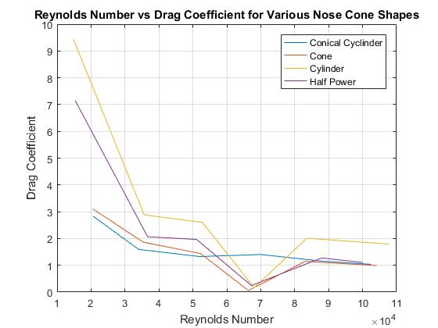

Figure 14: Graph of drag coefficient vs. Reynolds number for four different nose cones

Looking at Figure 14 it is interesting to note the mostly downward trend for drag coefficient as the Re increases. However, the disturbances around Re=6.6104 are interesting as all nose cones except the conical cylinder (fineness ratio of 4) sharply decrease their drag coefficients while the conical cylinder increases slightly. After this drop, the drag coefficients return to a similar trend as if there was no drop. Another trend is that of the change from a sharp drop from Re=2104to Re=3.5104where the downward trend smooths out.

#### Drag vs. Reynolds Number

Using the same information displayed in Table 4and the same Reynolds numbers utilized in Figure 14 a graph of the drag force on the airfoils versus the Reynolds numbers was completed and can be found in Figure 15. This graph displays results comparable to those of Figure 15 with the corresponding drops and jumps at the same Re, however the overall trend is upward in drag force.

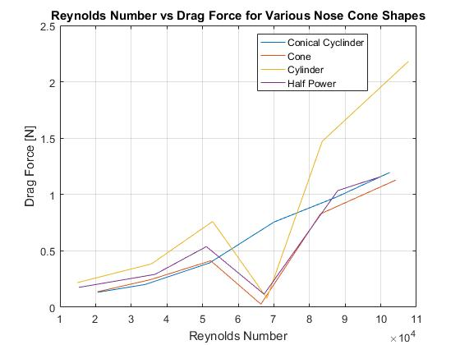

Figure 15: Graph of average drag force on each nose cone vs Reynolds number

#### Experimental vs. Simulated

By comparing the recorded experimental drag forces for the conical cylinder and the half power nose cones to the drag forces from the previous simulation it was possible to find discrepancies in assumptions made for the simulation. Comparing Cases 1 and 2 (20 m/s or 90 m/s and no angle of attack) to the results for the conical nose cone (fineness of 4) in Table 4 it’s evident that the simulation fails to properly account for all forces acting on the nose cone. In Case 1 the simulation produced a drag force of 0.1964 N, while Table 4 shows a force of 0.755 N. Meanwhile, for the half power nose cone at 20 m/s the wind tunnel testing produced a drag force of 0.116 N compared to the simulation with drag of 2.975 N.  There are a few possible reasons for these differences. First, as noted above we believe that some of our drag force results for the wind tunnel tests are too large due to discrepancies in data collection. In the case of the conical nose cone where the simulation drag was lower than the experimental drag some additional drag could have been induced by the pole the nose cone was attached to in addition to the possible experimental error. For the half power nose cone, the much higher simulation drag could be attributed to how the Fluent software calculates drag over the surface of the nose cone. The half power nose cone produced large areas of trailing drag, which may not play as large an effect in the experimental case.

#### Fineness Ratio

Referring to the drag vs. Reynolds number graph in Figure 15 and Table 4 it is possible to explore the effects of fineness ratio on the drag by comparing the two conical nose cones. Based on our experimental results, at lower Re there is little difference in the effects of fineness ratio on drag. However, at higher Re a nose cone with fineness ratio of 4 produced higher drag than that for the nose cone with fineness ratio of 1. As the fineness ratio is increased, not only will more material be needed to create the nose cone, but also the nose cone will have a larger body area. This larger body area contributes directly to an increase in drag on the nose cone.

## Fiberglass Nosecone Molding

As part of the lab, a mold for a rocket nose cone was designed in CAD, and 3D printed. This mold was used to shape a fiberglass nose cone, which is shown in the figure below. For our team’s actual rocket, a similar manufacturing process will be used to make the part. Below is a summary of the lessons that we learned, which will inform the design of our next nose cone mold.

* An improved method for joining the two mold halves is required. Two mounting holes located at the base of the were used for the design in this lab, but an additional set of holes will be added in the revised mold, located along the length of the seam between the two halves.
* The overlap between the two halves of fiberglass cloth must be improved. ¼” of overlap was used, but this overlap was messy, due to the poor joining between the two mold halves.
* The mold should be designed so that it is easily stood upside down, during the drying process
* The excess fibers coming out the bottom of the nose cone should be trimmed before they can dry. They are difficult to cleanly remove once they have cured.

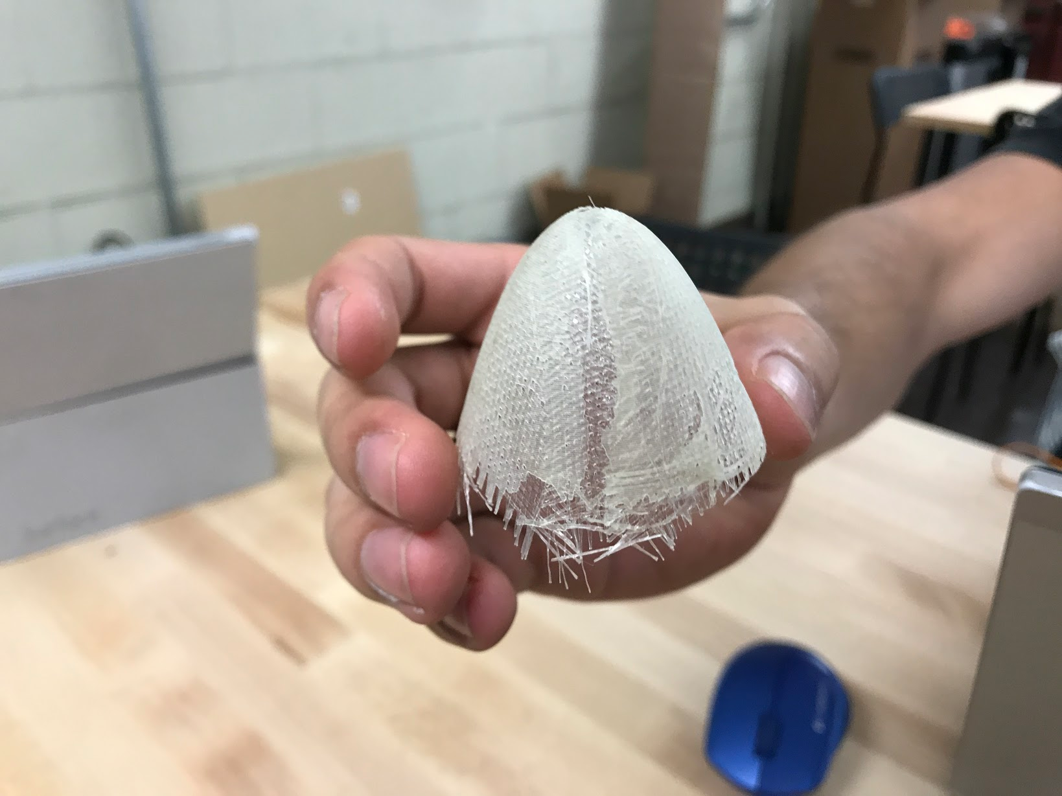

Figure 16: Finished Nose Cone.

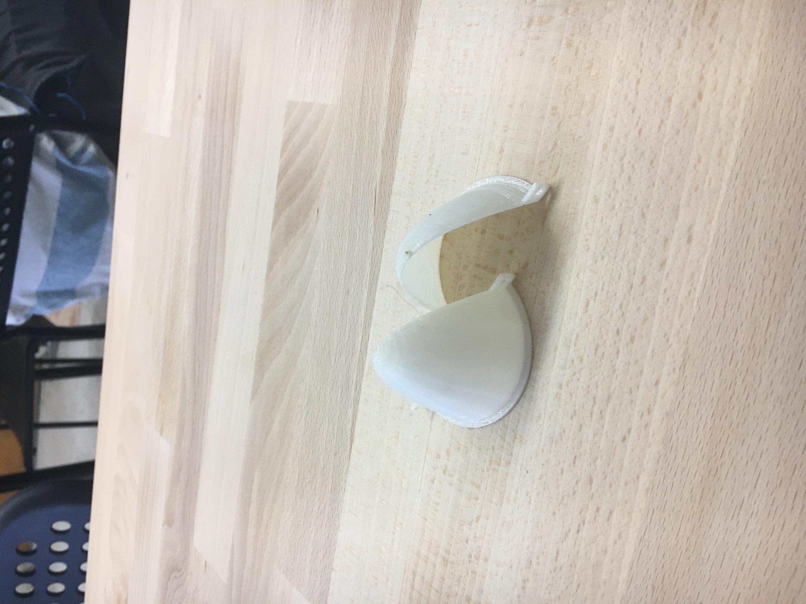

Figure 17: 3D Printed mold used for Fiberglass Nosecone.

## Trajectory Analysis

The trajectory analysis includes simulations for three different model rockets that were previously launched and collected trajectory data during flight. The code used for the analysis is the code developed by the SpaceY team for the Preliminary design review of the MAE 157A class. Below, plots for three cases of simulations are presented, along with the plots for the experimentally collected data. The three cases include

1. Trajectory analysis with no drag
2. Trajectory analysis with Cd_coast = 0.5 and Cd_recovery = 1.5
3. Trajectory analysis with Cd_coast = 0.8 and Cd_recovery = 2.0

The model rockets used in the analysis include

1. Amazon C6-3
2. Big Bertha B6-4
3. Bull Pug B6-4

## Amazon C6-3

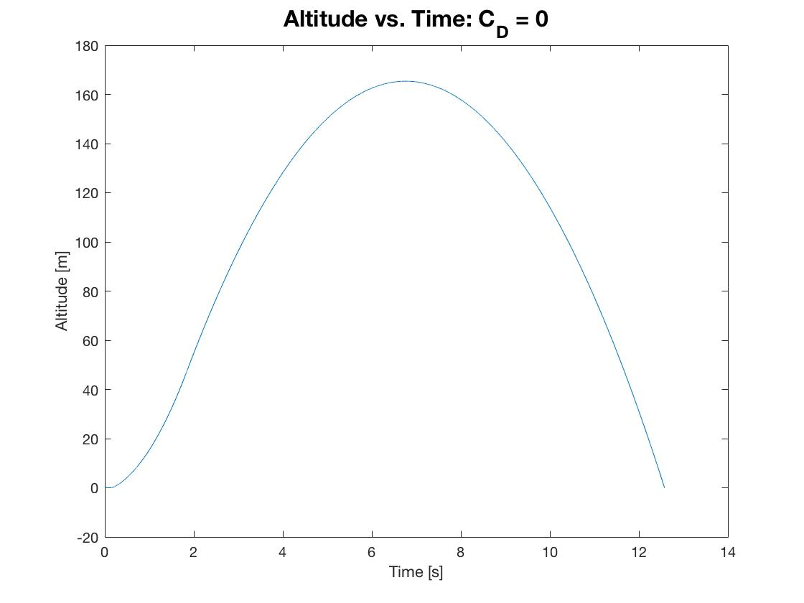

Figure 18: Amazon C6-3 Trajectory Analysis with No Drag

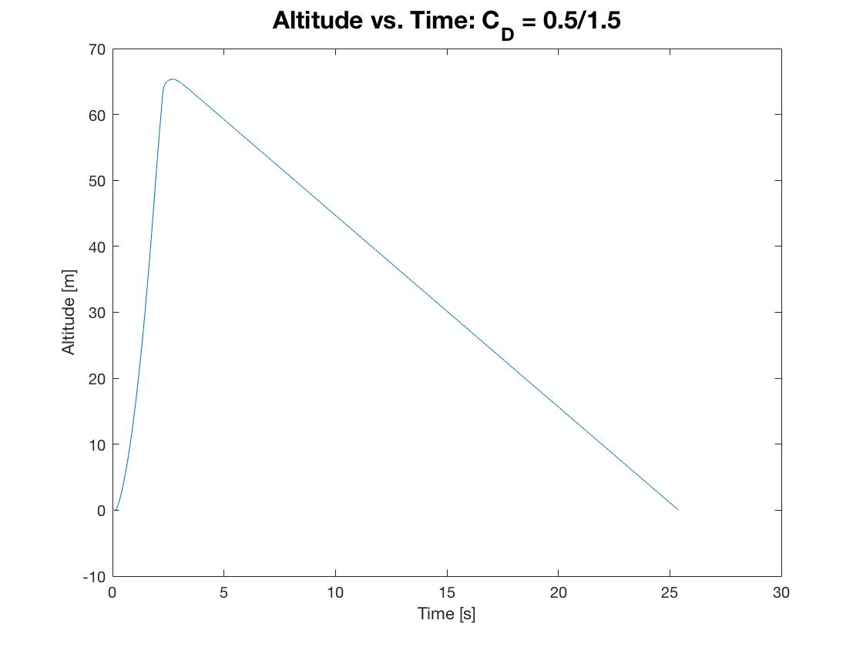

Figure 19: Amazon C6-3 Trajectory Analysis with Drag Condition 1.

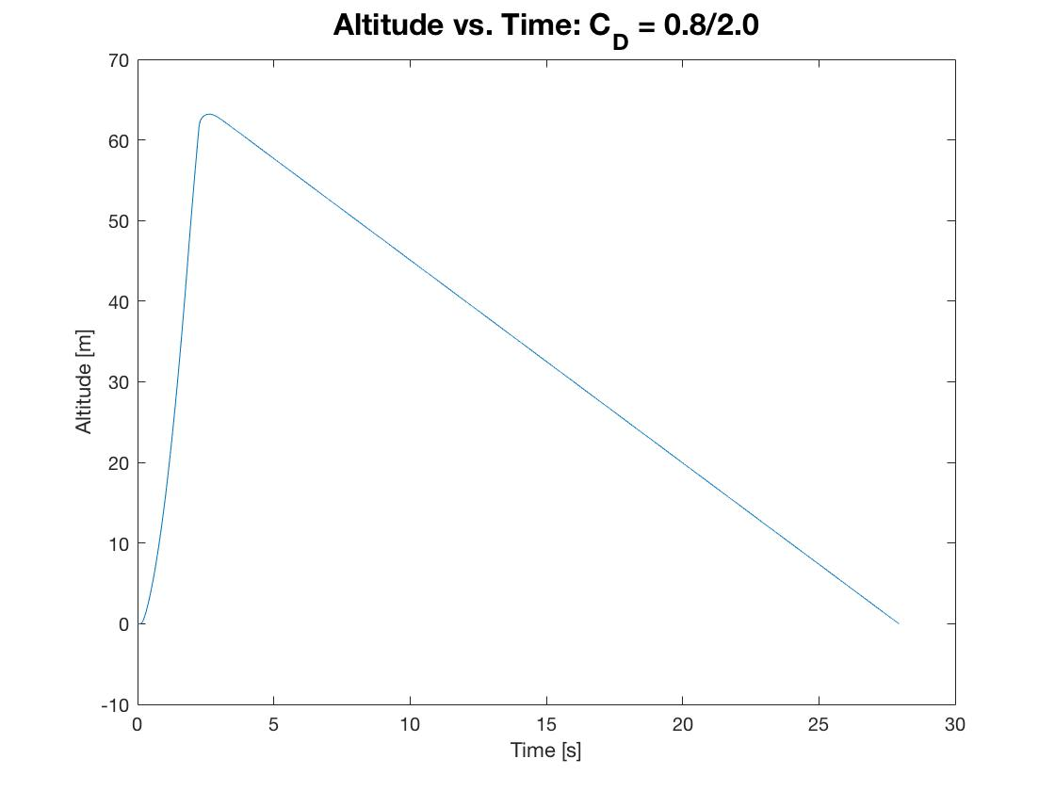

Figure 20: Amazon C6-3 Trajectory Analysis with Drag Condition 2.

|  |  |  |  |
| --- | --- | --- | --- |
| Drag | Apogee Height [m] | Burnout Time [s] | Descent Velocity [m\s] |
| None | 164.4 | 1.86 | N/A |
| CD = 0.5/1.5 | 65.0 | 1.86 | -2.90 |
| CD = 0.8/2.0 | 63.1 | 1.86 | -2.51 |

Table 5: Amazon C6-3 Numerical Results for Three Different Simulations.

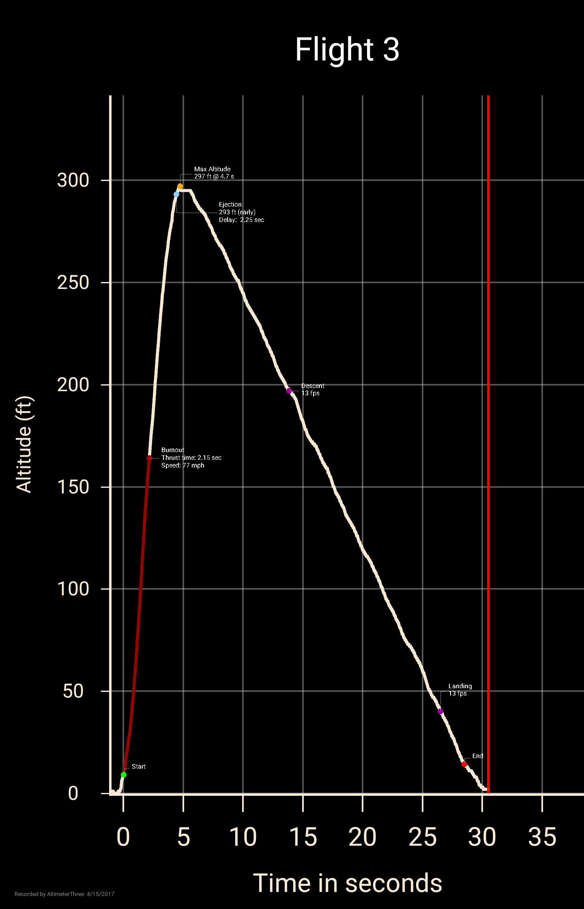

Figure 21: Experimentally collected altimeter data for the Amazon C6-3.

## Big Bertha B6-4

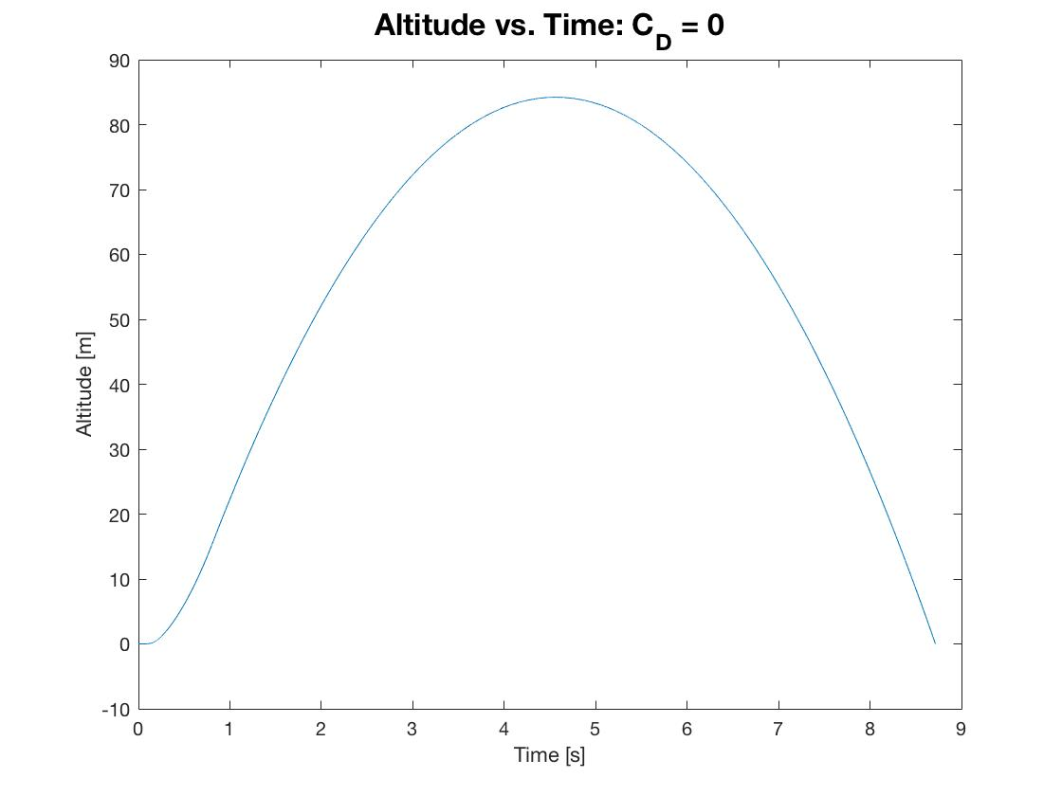

Figure 22: Big Bertha B6-4 Trajectory Analysis with No Drag

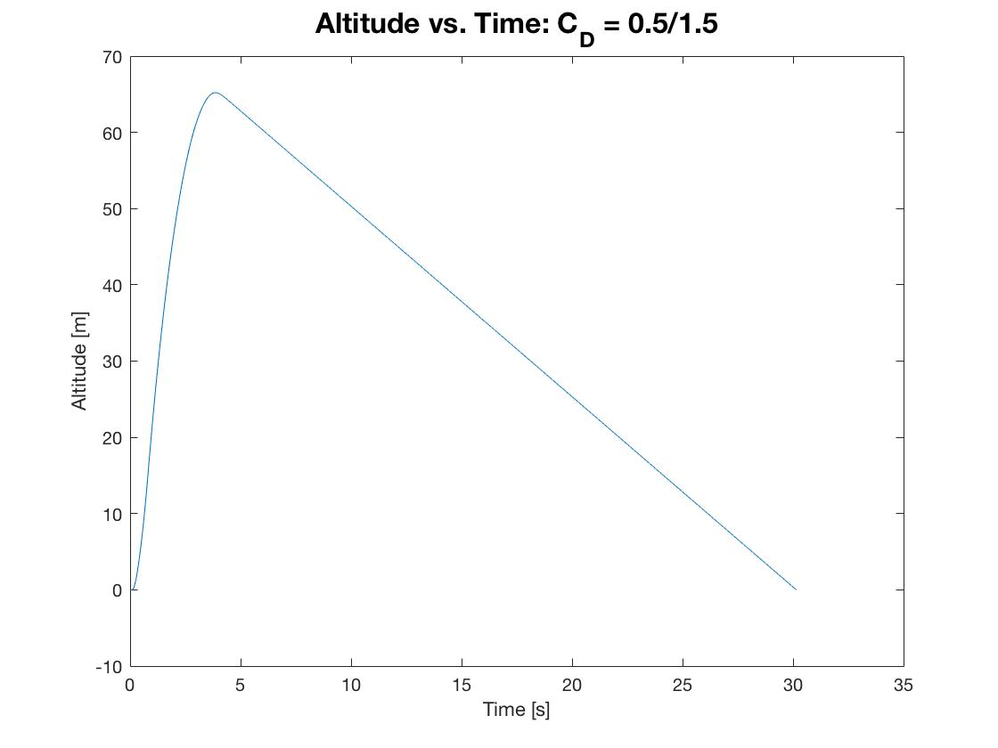

Figure 23: Big Bertha B6-4 Trajectory Analysis with CD = 0.5/1.5

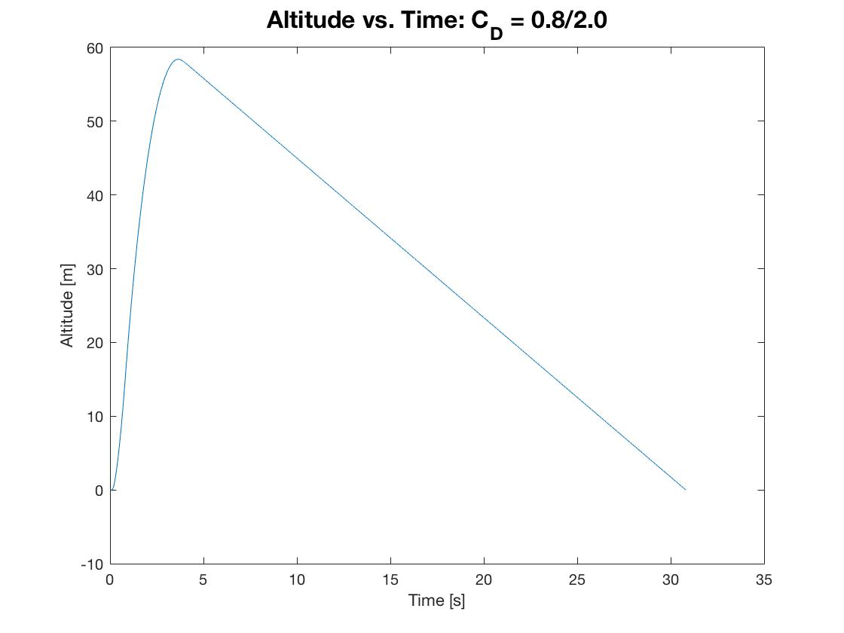

Figure 24: Big Bertha B6-4 Trajectory Analysis with CD = 0.8/2.0

|  |  |  |  |
| --- | --- | --- | --- |
| Drag | Apogee Height [m] | Burnout Time [s] | Descent Velocity [m\s] |
| None | 84.6 | 0.86 | N/A |
| CD = 0.5/1.5 | 65.5 | 0.86 | -2.49 |
| CD = 0.8/2.0 | 58.8 | 0.86 | -2.16 |

Table 6: Big Bertha B6-4 Numerical Results for Three Different Simulations.

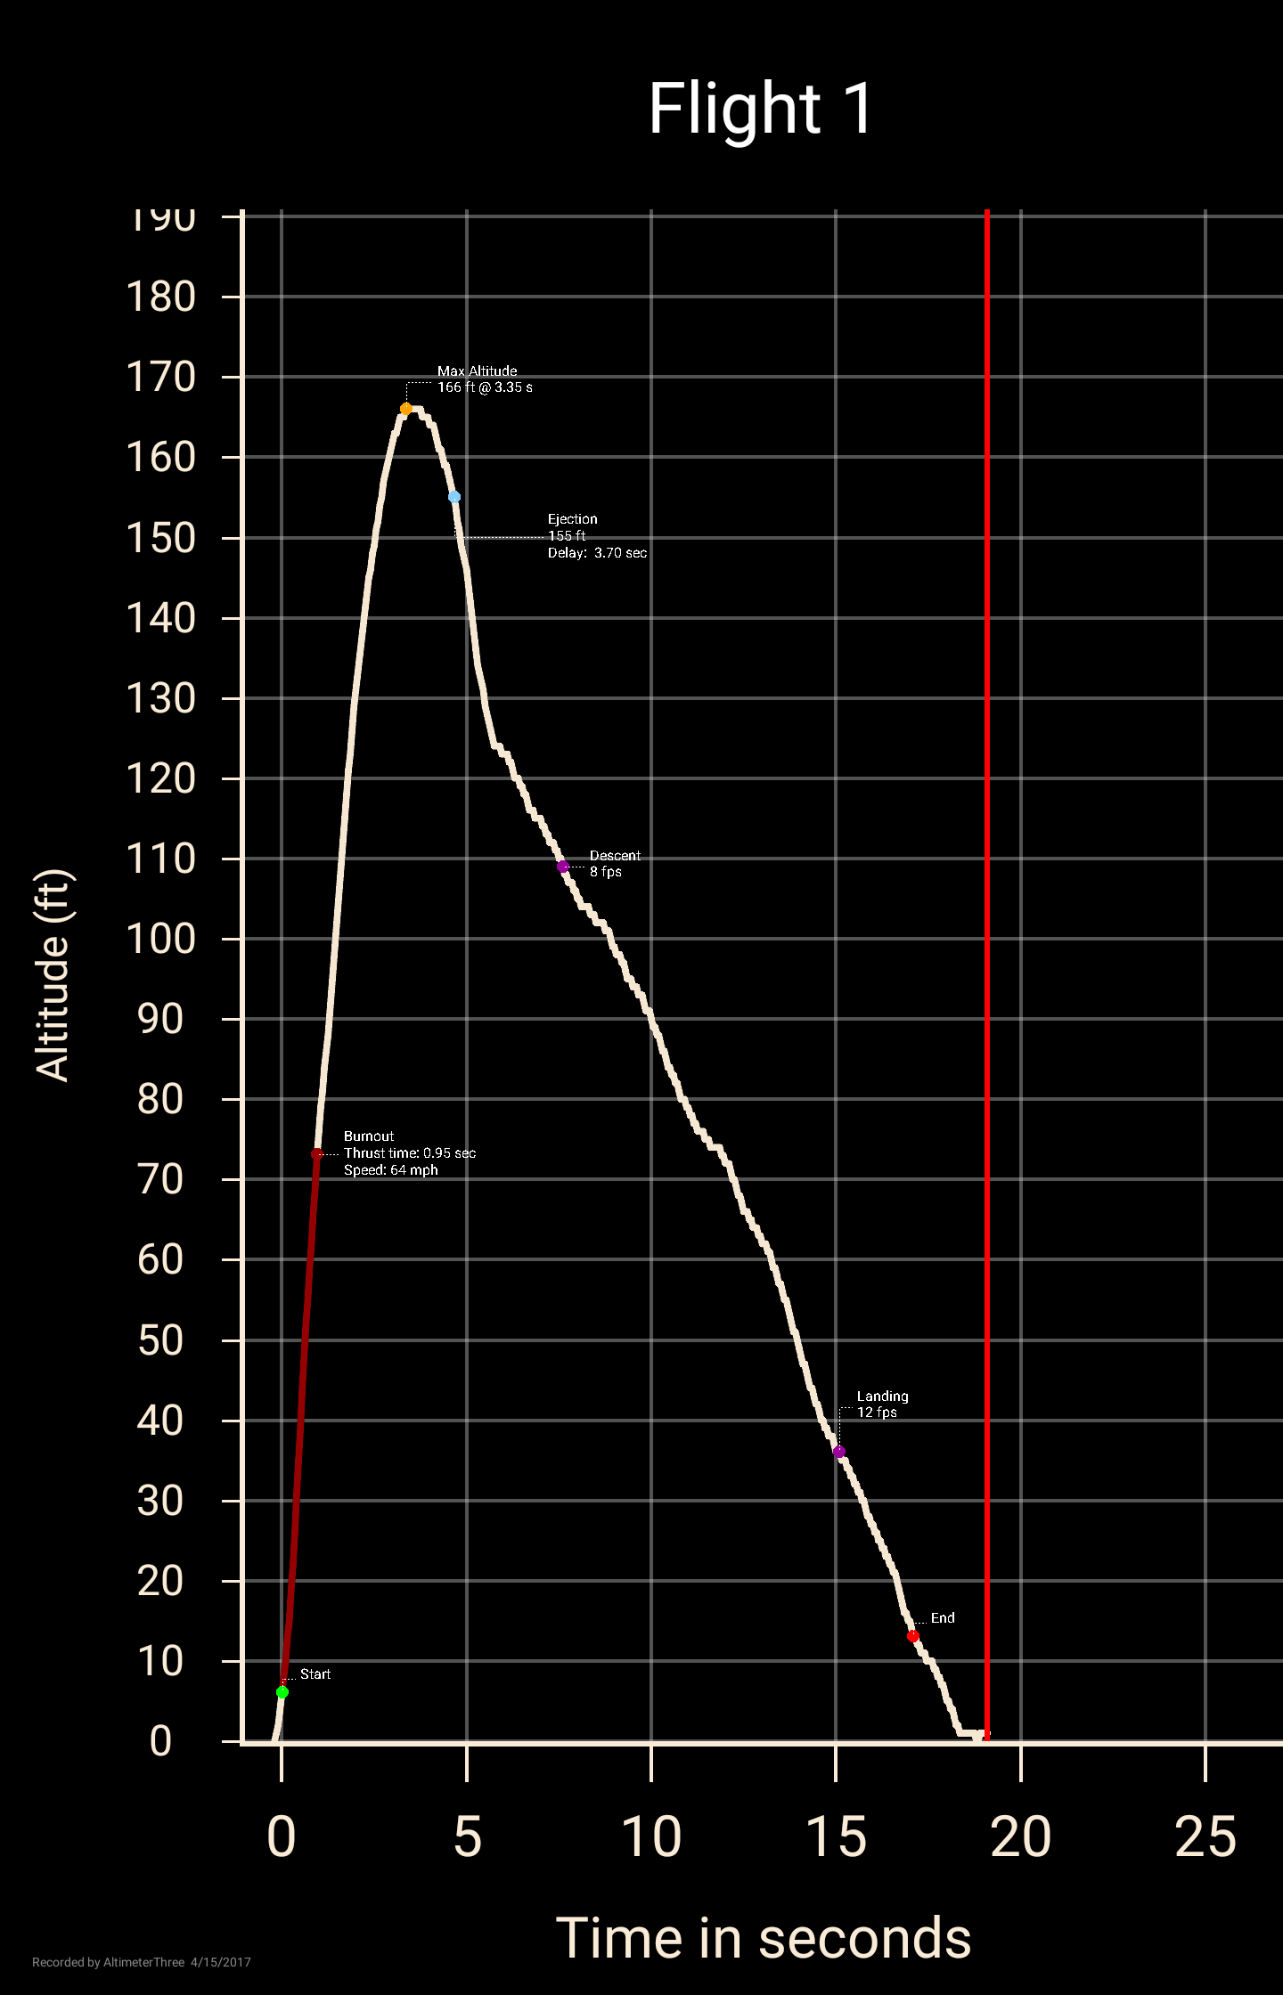

Figure 25: Experimentally collected altimeter data for the Big Bertha B6-4.

## Bull Pug B6-4

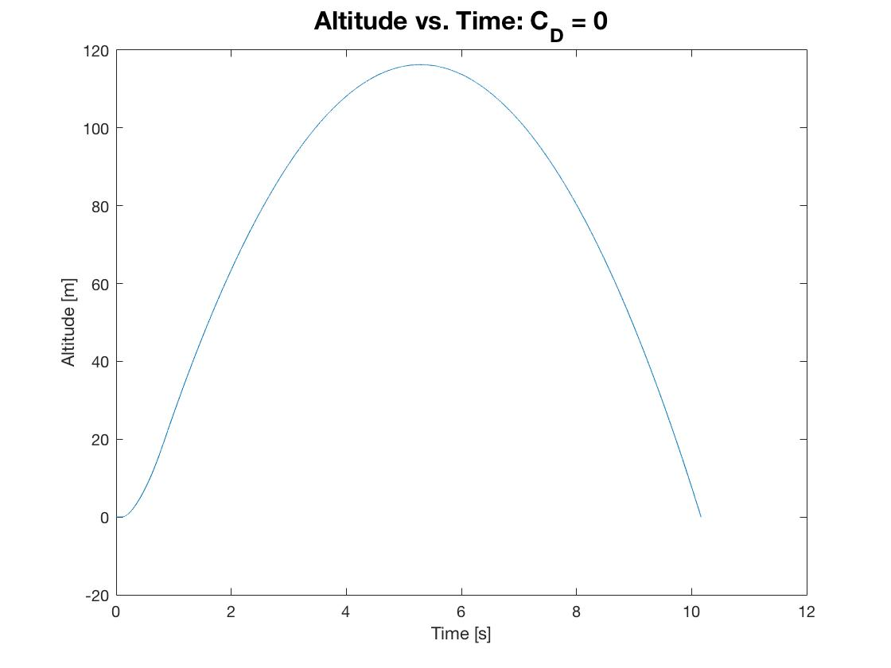

Figure 26: Bull Pug Trajectory Analysis with No Drag

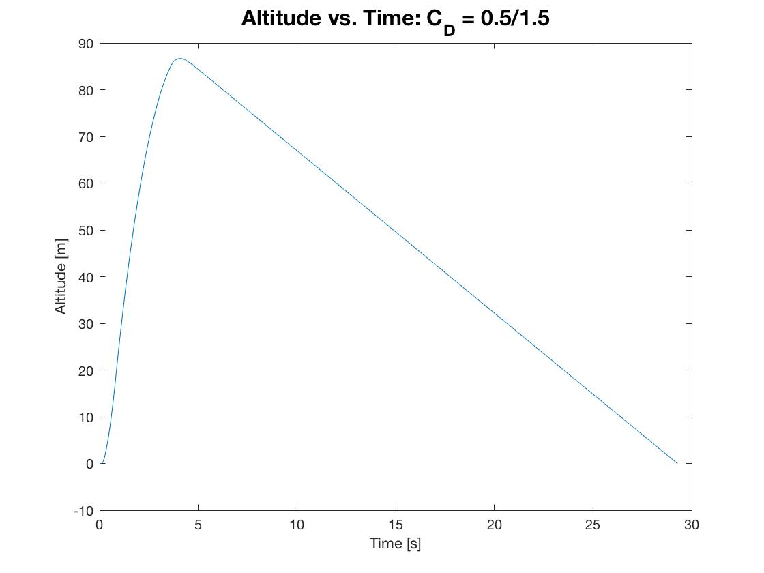

Figure 27: Bull Pug Trajectory Analysis with CD = 0.5/1.5

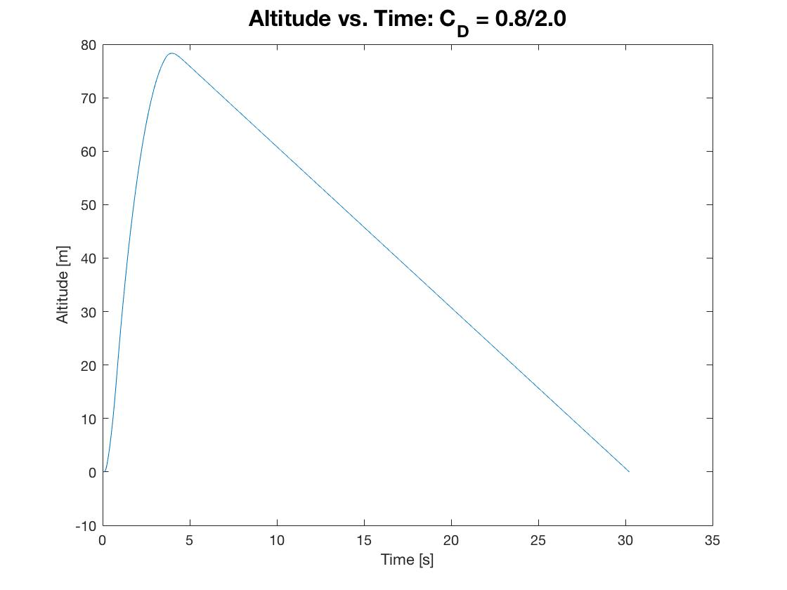

Figure 28: Bull Pug Trajectory Analysis with CD = 0.8/2.0

|  |  |  |  |
| --- | --- | --- | --- |
| Drag | Apogee Height [m] | Burnout Time [s] | Descent Velocity [m\s] |
| None | 117.4 | 0.86 | N/A |
| CD = 0.5/1.5 | 87.2 | 0.86 | -3.47 |
| CD = 0.8/2.0 | 78.3 | 0.86 | -3.00 |

Table 7: Bull Pug B6-4 Numerical Results for Three Different Simulations.

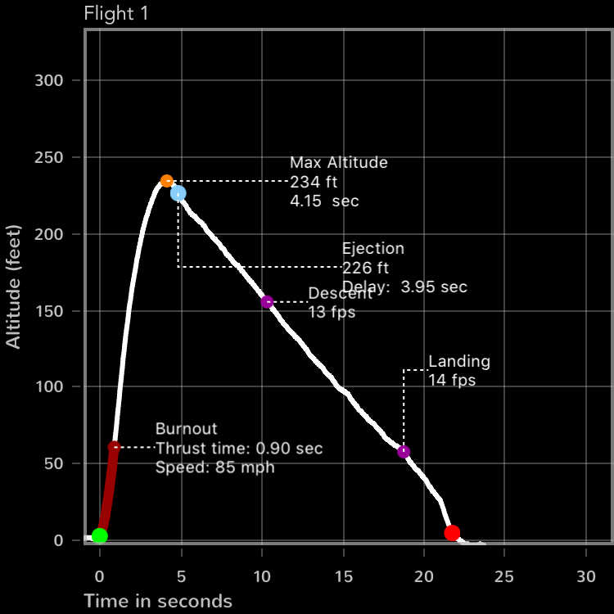

Figure 29: Experimentally collected altimeter data for the Bull Pug B6-4.

## Trajectory Discussion

### Plot Discussion

The results from the simulations for the three different vehicles show uniform plots. The trends with the same input drag conditions, end up creating consistent trends. The biggest factor of uncertainty are the differences between the available data online for the rocket motors and the experimental results, as it has been shown that the rocket motors to show significance deviance between motors. For the no drag plot, we see a complete parabolic position plot, as terminal velocity is never achieved, and the vehicle is always accelerating. As the drag is increased, the apogee height of the flight time increases. Generally, between the second and third simulation cases, we see a small increase in total flight time, but that total flight time is also highly dependent on the altitude achieved at apogee and the final weight of the vehicle after burn.

### Effect of Mass

By increasing the mass of the vehicle, the burnout velocity will decrease and the altitude during coast will also decrease. Due to higher mass, there will be a greater gravitational force on the rocket as it ascends, thus will accelerate at a lower rate, achieve a lower velocity, and thus a lower overall altitude.

### Effect of Launch Angle

When running simulations with the Estes Bull Pup model rocket, at both launch angles of zero and ten degrees, the difference between apogees is quite small. The percent difference between the two is 0.53%. This small difference is due primarily to the fact that 10 degrees is still a very small angle, and in most cases can be assumed part of the small angle assumption, meaning that cos (10) = 1 and sin (10) = 0, thus causing a small effect on the trajectory performance of the simulations.

### Malfunctioning Altimeter

If your altimeter does not function properly during flight then a method to obtain an estimate of the flight apogee would be to assume that when the parachute deploys you have roughly reached apogee. Then, collect the time between parachute deployment and touchdown. With this, it is possible to obtain the apogee height using the known or experimentally calculated descent velocity of the vehicle and the descent time. Assuming constant descent velocity for a majority of descent, due to the high drag and terminal velocity for the recovery configuration of the vehicle, the apogee would be the descent velocity time the descent time.

### 

## Launch Angle Controller

This section of the lab report briefly describes the design of the launch angle controller, and provides a detailed description of the manufacturing plan. The LAC sits on a baseplate, which is designed with mounting points to the launch platform. The angle ranges continuously between +/- 35 deg, and is controlled by turning the threaded brass tube. The angle is locked by a set screw that presses against the brass rod. Below are some general notes about the manufacturing requirements.

* Length/Width tolerances: +/-0.01”
* Hole Location Tolerances: +/-0.01”
  + Be sure to measure those from a smart edge
* Depth tolerances: +/-0.1”
* Counterbores use 5/16” drill-bit to .188” depth
* Small holes (8-32 screws) drilled with 0.132” drill bit (#29).
* Large holes (¼-20 bolts) drilled with #7 drill bit.
* Bolt countersink will be determined based on the size of the bolt head.
* Use a hammer, center punch, and center drill when making holes

#### LAC Assembly

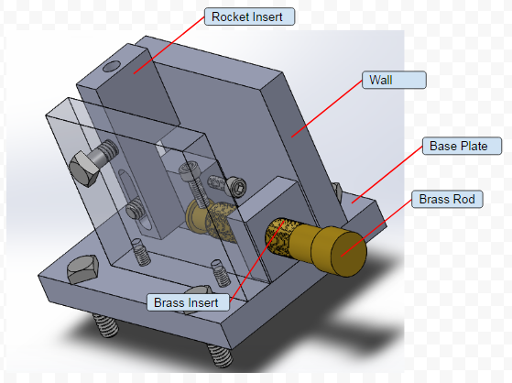

Figure 30: LAC Assembly Isometric View

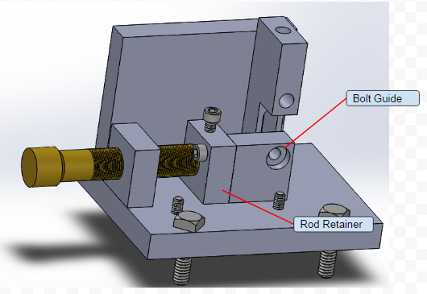

Figure 31: LAC Assembly Back Isometric View

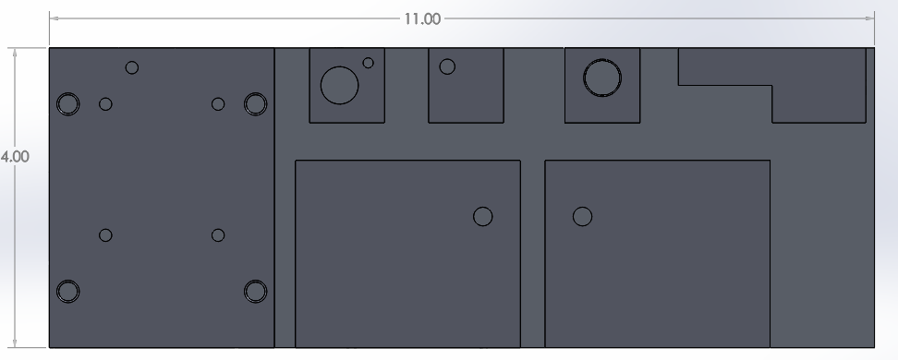

Figure 32: 4”x11” Material Check

### Manufacturing Plan

#### Base Plate

1. Use the dye to paint a horizontal band approximately 3” from the left side in figure ()
2. Using the vertical ruler measure 3.125” from the left side of figure () and mark a line along the blue band created in the last step
3. Use the bandsaw to cut the piece along this line
4. Now make a line 3.00” from the long side of the piece removed from the 4”x11” slab
5. Use the mill to bring the width of the new piece to 3”
6. Make 4 marks 0.750” from each short side and .250” from each long side
7. Use the drill press to drill four ¼” holes in each of the previously marked locations.
8. Deburr those four holes with a small chamfer
9. Make 2 marks .750” from one of the short sides and each long side
10. Make 2 more marks 2.50” from the short side used in the previous step, as well as .750” from each long side
11. Make similar marks for the 1.101” and 0.264” location of the fifth hole
12. Use the drill press to make 5 holes, all with a diameter of .164” in theses marked locations.

The Base plate should now have the dimensions shown in the following image

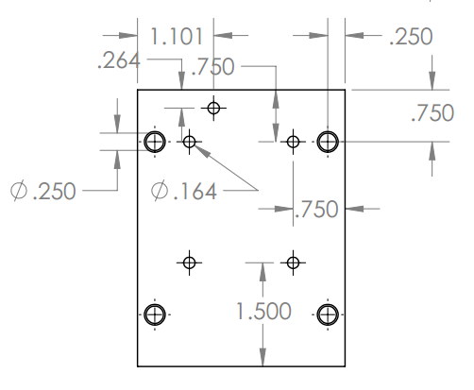

Figure 33: Base Plate Drawing

#### Wall

1. Paint then mark a line approximately 2.625” from the bottom of figure ()
2. Use the bandsaw to cut the piece along this line,  creating a block approx. 2.625”x7.875”
3. From this block cut out two blocks with approximately 3.25” in width. Use the same process in the previous steps
4. Use the mill to face the two pieces to 3”x2.5” blocks. Ensure all three side cut with the band saw are faced to ensure the sides of the blocks are straight
5. Make a mark .500” from the short side and .750”  from the long side on both blocks
6. Use the drill press to make a hole .250” in diameter in the marked location
7. On the long face farthest from the hole in the previous step make a mark .219” from the long side and .500” from the short side so it is aligned with the hole made in the previous step. Make another mark .750”  from the other short side and .219” from the long side
8. Drill holes .391” deep and with a diameter of .164” in the marks. Use a marker to draw a line on the drill to help hit the correct depth
9. Thread these holes with the appropriate tap

The Wall should now have the dimensions shown below

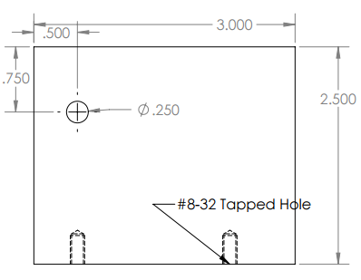

Figure 34: Wall Drawing

#### Rod Retainer

1. From the block that is approx. 1.375”x7.875” cut out a piece with the band saw that is approx. 1.25”x1.25”
2. Use the mill to create a piece that is 1”x1”
3. On the largest face make a mark .5” from one side and .6” from the adjacent side. Make another mark .219” from the side farthest from the center of the other hole, and .200” from the adjacent side
4. Drill a hole .500” in diameter in the first mark made, and a hole .136” in diameter in the second
5. On the face .219” from the small hole make a mark .219” from the long side and .400” from the short side
6. Drill a hole .164” in diameter and .250” deep
7. Thread this hole with the appropriate tap

The Rod Retainer should now have the dimensions shown below

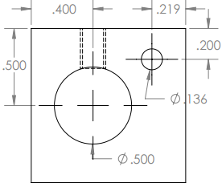

Figure 35: Wall Drawing

#### Bolt Guide

1. Using the band saw cut another piece approx. 1.25”x1.25”
2. Face the piece to 1”x1” ensuring all side are straight
3. Make a mark .250” away from side and .250” from the adjacent side
4. Drill a through-hole with the #7 drill bit
5. On one of the faces furthest from the center of the previous hole, make a mark .219” from the long side and 0.2” from the short side nearest the hole from the previous step
6. Drill a hole .350” deep and .136” in diameter
7. Now drill a counter bore hole on the “right-hand side” of the hole. This is the right-hand side if you are looking from the 0.35” depth hole, and the diameter of the counter-bore must be larger than the ¼-20 bolt head

The Bolt Guide should now have the dimensions shown below

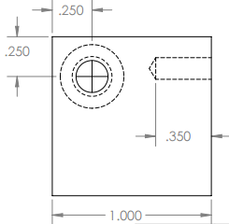

Figure 36: Bolt Guide Drawing

#### Brass Insert

1. Using the band saw, cut a piece approx. 1.25”x1.25”
2. Use the mill to face the piece so it’s 1”x1”. Ensure all sides are straight
3. Make a mark .5” from one side and .4” from either of the adjacent sides
4. Drill a hole .500” in diameter through the piece
5. Tap the hole

The Brass insert should now have the dimensions shown below

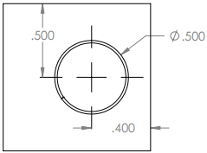

Figure 37: Brass Insert Drawing

#### Rocket Insert

1. Using the bandsaw cut a piece approx 1.125”x. 2.625”
2. Use the mill to face this piece so it is 1.00”x2.50”. Ensure all sides are straight
3. On the face that is .438”x2.50” make a mark 1.25” from the short side
4. Use the mill to create a step .500” deep from your mark to the end of the face
5. On the face that is 2.50” in length make a mark .250” from the side with the step.  Make another mark .750” from the previous mark. These two points represent the ends of a 0.25” diameter slot.
6. Use a 0.25” end mill to cut out this slot
7. On the same face make mark 1.00” from the side opposite the bore, and in the center of the face
8. At this location drill a hole through the piece with a diameter of .250”
9. On the face opposite the step make a mark in the center of the face
10. At this location drill a hole .750” in depth and with a diameter of .250”

The Rocket Insert should now have the dimensions shown below

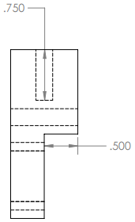

Figure 37: Rocket Insert Drawing

#### Brass Rod

1. If applicable: face off one end, paint and measure length, bandsaw, and face
2. Paint and mark 0.5” for shoulder. Also mark 0.438” for contour. Turn it down to 0.5” diameter

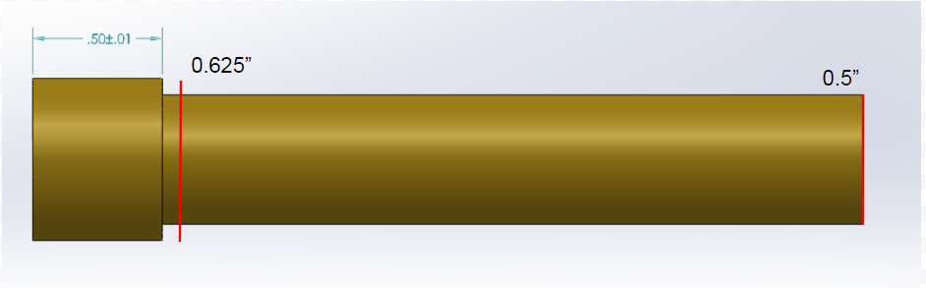

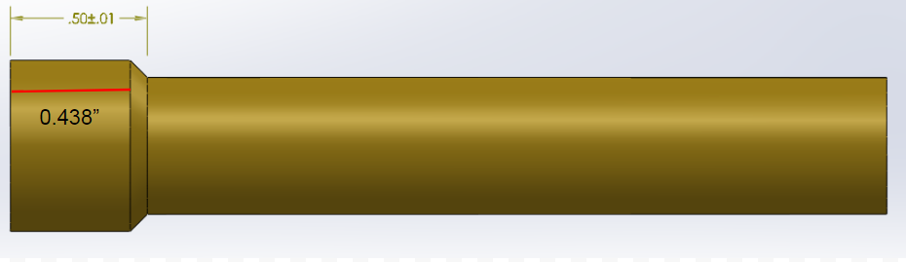

1. Adjust angle of cutting tip to hit the desired angle of the contour, and make the cut
2. Thread the rod with 8-32 die

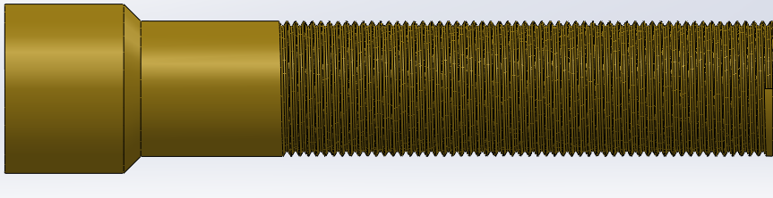

5) Mark end to remove thread on lathe (0.438”). Cut until diameter is smooth

6) Cut the internal step down to 0.375”

# **Summary and Conclusions**

This lab covered many different engineering topics, including Solidworks Computer Aided Design, Computational Fluid Dynamics, experimental testing and analysis, Matlab coding and simulation, and composite manufacturing. All these different elements present valuable insight into the engineering process from design, through testing and simulation to the final product. The lab also employed valuable team building skills. The final report included 5 different and time consuming sections. If one person were to attempt to complete all the assignments on there, they would have spent over 40 hours completing the lab, not including writing the report. Success in this lab, just as in industry, academia and the non-technical world required team work for success.

# **Statements of Participation**

## Individual Tasks

1. ANSYS Modeling
   1. Total time spend modeling the airfoils for CFD was 2-3 hours.
2. Lab Report and Calculations
   1. Approximately 4-5 hours of time was spent compiling all data, performing calculations, and compiling results into this report.

## Team Tasks

1. The team portion of this lab included one day of wind tunnel testing. This was performed by all team members and took about 40 minutes to complete.
2. Trajectory analysis and report.

## Team Members Rated

Rated on a 1-10 scale for participation and total output for the team tasks.

1. Jordan Robertson : 10
2. Hunter Kenyon : 10
3. Lukas Kramer : 10
4. Sunderlin Jackson : 10

# **Appendices**

## Trajectory Code

%%%%%%%%%%%%%%%%%%%%%%%%%%%%%%%%%%%%%%%%%%%%%%%%%%%%%%%%%%%%%%%%%%%%%%%%%%%

% Prescott Rynewicz

% 504288967

% MAE 157A Trajectory Analysis Code

% Team SpaceY

%%%%%%%%%%%%%%%%%%%%%%%%%%%%%%%%%%%%%%%%%%%%%%%%%%%%%%%%%%%%%%%%%%%%%%%%%%%

close all; clear all; clc;

%% Input Parameters

Mass                = 0.500;                                % [kg]

g                   = 9.81;                                 % [m/s]

Re                  = 3.67e6;                               % []

Thrust_curve        = dlmread('Thrust_curve.pol');

t_simple            = Thrust_curve(:,1);                    % [t]

t_total             = [];

T_simple            = Thrust_curve(:,2);                    %[N]

T_total             = [];

% This Loop lionearly expands the simple data points given in the G40-7 Thrust

% Profile found at http://www.thrustcurve.org/simfilesearch.jsp?id=1969 in

% order to create a better approximation of the thrust profile. ie More

% Data Points

for i = 1:length(t_simple)-1

    expanded_array_t    = linspace(t_simple(i),t_simple(i+1),100);

    expanded_array_T    = linspace(T_simple(i),T_simple(i+1),100);

    t_total             = cat(2,t_total,expanded_array_t);

    T_total             = cat(2,T_total,expanded_array_T);

end

                                  % [deg]

prop_mass_init      = 53.8/1000;                            % [kg]

total_mass_motor    = 123/1000;                             % [kg]

struct_mass_motor   = total_mass_motor - prop_mass_init;    % [kg]

Isp                 = 184;                                  % [sec]

m_dot               = T_total./g./Isp;                      % potential correction factor of -.0004;

                                                            % this wouls be to make

                                                            % prop_mass_profile equal zero at

                                                            % end of burn.

prop_mass_profile   = [prop_mass_init];                     % [kg]

total_mass          = linspace(Mass,Mass,length(t_total));

for index = 2:length(T_total)

    prop_mass_profile(index)    = prop_mass_profile(index-1) - m_dot(index)*(t_total(index)-t_total(index-1));

    total_mass(index)           = total_mass(index-1) - m_dot(index)*(t_total(index)-t_total(index-1));

end

% We now have Thrust, time, and mass profiles for burn time of flight. Now

% we need to calculate initial gravity, density and Drag values to begin

% loop iterations for Burn Calcs.

burn_length         = length(t_total);                      % [vec_length]

a                   = linspace(0,0,burn_length);

u                   = linspace(0,0,burn_length);

h                   = linspace(0,0,burn_length);

Af                  = pi*(.0580/2)^2;                       % [m^s]

theta               = deg2rad(5);                           % [rad]

ge                  = 9.81;                                 % [m/s]

h                   = linspace(0,0,burn_length);            % [m]

g                   = linspace(0,0,burn_length);            % [m/s^2]

g(1)                = 9.81;                                 % [m/s]

rho                 = linspace(0,0,burn_length);            % [kg/m^3]

rho(1)              = 1.225;                                % [kg/m^3]

CD                  = 0.75;                                 % Initial Estimate from Stine

D                   = linspace(0,0,burn_length);            % [N]

D(1)                = 0.5*rho(1)*u(1)^2*CD*Af;              % [N]

dt_avg              = 0;

for index = 1:(burn_length-1)

    dt              = (t_total(index+1)-t_total(index));

    dt_avg          = dt_avg + dt;

    a(index+1)      = (T_total(index) - D(index))/total_mass(index) - g(index)*cos(theta);

    u(index+1)      = u(index) + (T_total(index)/total_mass(index) - D(index)/total_mass(index) ...

                                - g(index)*cos(theta))*dt;

    h(index+1)      = h(index) + u(index)*dt*cos(theta);

    g(index+1)      = ge*(Re/(Re+h(index+1)));

    rho(index+1)    = real(1.2*exp(-2.9*10^-5*h(index+1)^1.15));

    D(index+1)      = 0.5*rho(index+1)*u(index+1)^2*CD*Af;

    if (h(index+1) > 5 && h(index+1) < 5.1)

        disp(u(index+1))

    end

end

dt                  = dt_avg/burn_length;                   % [s] New Time step from average thrust dt.

for index = burn_length:10000000

    total_mass(index)= total_mass(index-1);

    a(index+1)      = -D(index)/total_mass(index) - g(index)*cos(theta);

    u(index+1)      = u(index) + (-D(index)/total_mass(index)*dt ...

                                - g(index)*cos(theta)*dt);

    h(index+1)      = h(index) + u(index)*dt*cos(theta);

    g(index+1)      = ge*(Re/(Re+h(index+1)));

    rho(index+1)    = real(1.2*exp(-2.9*10^-5*h(index+1)^1.15));

    D(index+1)      = 0.5*rho(index+1)*u(index+1)^2*CD*Af;

    t_total(index+1)= t_total(index)+dt;

    if u(index+1) < 0 || t_total(index) >= 7

        index = index+1;

        break;

    end

end

CD                  = 1.50;                                  % Will be determined from drop tests with parachute.

Af                  = pi*(0.50/2)^2;                        % [m^2]r

D(index)            = 0.5*rho(index)*u(index)^2*CD*Af;

for index = index:100000000

    total_mass(index)= total_mass(index-1);

    u(index+1)      = u(index) + (-D(index)/total_mass(index)*dt ...

                                - g(index)*dt);

    h(index+1)      = h(index) + u(index)*dt*cos(theta);

    g(index+1)      = ge*(Re/(Re+h(index+1)));

    rho(index+1)    = real(1.2*exp(-2.9*10^-5*h(index+1)^1.15));

    D(index+1)      = 0.5*rho(index+1)*u(index+1)^2*CD*Af;

    t_total(index+1)= t_total(index)+dt;

    if u(index+1) <= 0

        break;

    end

end

for index = index:100000000

    total_mass(index)= total_mass(index-1);

    u(index+1)      = u(index) + (D(index)/total_mass(index)*dt ...

                                - g(index)*dt);

    h(index+1)      = h(index) + u(index)*dt*cos(theta);

    g(index+1)      = ge*(Re/(Re+h(index+1)));

    rho(index+1)    = real(1.2*exp(-2.9*10^-5*h(index+1)^1.15));

    D(index+1)      = 0.5*rho(index+1)*u(index+1)^2*CD*Af;

    t_total(index+1)= t_total(index)+dt;

    if h(index+1) <= 0

        break;

    end

end

figure; plot(t_total,u);    title('Velocity vs. Time', 'Fontsize', 16); xlabel('Time [s]'); ylabel('Velocity [m/s]');

figure; plot(t_total,h);    title('Altitude vs. Time', 'Fontsize', 16); xlabel('Time [s]'); ylabel('Altitude [m]');

figure; plot(t_total,D);    title('Drag vs. Time', 'Fontsize', 16);     xlabel('Time [s]'); ylabel('Drag [N]');

figure; plot(t_total,g);    title('Gravity vs. Time', 'Fontsize', 16);  xlabel('Time [s]'); ylabel('Gravity [m/s]');

figure; plot(t_total,rho);  title('Density vs. Time', 'Fontsize', 16);  xlabel('Time [s]'); ylabel('Density [kg/m^3]');

### Sample Wind Tunnel Data

|  |  |  |  |  |  |  |
| --- | --- | --- | --- | --- | --- | --- |
| Fx | Fy | Fz | Mx | My | Mz | V |
| -0.008582 | -0.003233 | -0.009753 | -4.92E-05 | 0.000177 | -0.000375 | 0 |
| 0.032392 | 0.079536 | 0.024895 | 0.016993 | -0.003995 | 0.00124 | 5.238813 |
| 0.032392 | 0.079536 | 0.024895 | 0.016993 | -0.003995 | 0.00124 | 5.238813 |
| 0.037855 | 0.106759 | 0.025789 | 0.020526 | -0.003111 | 0.001655 | 5.413593 |
| 0.029369 | 0.119703 | 0.026669 | 0.027615 | -0.002675 | 0.0024 | 5.115364 |
| 0.031073 | 0.120393 | 0.021482 | 0.025242 | -0.002987 | 0.002146 | 5.198258 |
| 0.032727 | 0.118114 | 0.025034 | 0.026506 | -0.003082 | 0.002266 | 5.203725 |
| 0.032094 | 0.127129 | 0.02572 | 0.028375 | -0.003443 | 0.002226 | 4.931912 |
| 0.026087 | 0.110225 | 0.022705 | 0.026629 | -0.003132 | 0.002264 | 5.235124 |
| 0.037559 | 0.092471 | 0.024561 | 0.017149 | -0.003232 | 0.001466 | 5.093702 |
| 0.031147 | 0.083196 | 0.029537 | 0.021947 | -0.003787 | 0.001904 | 5.06116 |
| 0.095893 | 0.248474 | 0.016446 | 0.054801 | -0.015254 | 0.002421 | 10.22304 |
| 0.105736 | 0.180799 | 0.01827 | 0.040597 | -0.01458 | 0.002327 | 10.173612 |
| 0.094995 | 0.175329 | 0.015695 | 0.037652 | -0.014296 | 0.0027 | 10.14202 |
| 0.106024 | 0.116105 | 0.017227 | 0.02358 | -0.016618 | 0.001008 | 9.796474 |